**VM 1(windows) – bevat RabbitMQ, (ubuntu via putty) Jenkins en Github**

Windows Server 2012R2

10.3.51.38

DT-VM-IPDIGX-22

DT-VM-IPDIGX-22(16-17)

DT-VM-IPDIGX-22-4(16-17) - linux (jenkins)

DT-VM-IPDIGX-22-5(16-17) - Windows AD

login: administrator

login: administrator

login: administrator

ww: Alter87

ww: xolu08

ww: azoj33

Ubuntu

Gebruikersnaam: administrator

Ww: xolu08

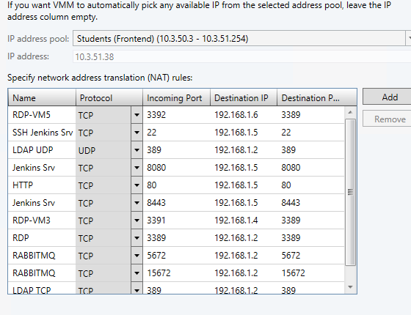

**VM 2(windows) – bevat Prestashop(hotel+restaurant)**

10.3.51.42

Tenant DT-VM-IPDIGX-22(2)(16-17)

DT-VM-IPDIGX-22-2(16-17)

login: administrator

ww: Vewi91

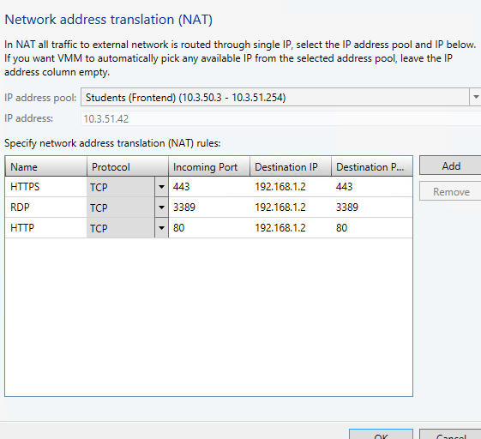

**VM 3(windows) – bevat Invoice ninja + special request + RabbitMQ**

10.3.51.44

DT-VM-IPDIGX-22(3) - Extra apart netwerk

DT-VM-IPDIGX-22-3(16-17)

L: administrator

ww: Ewax22

